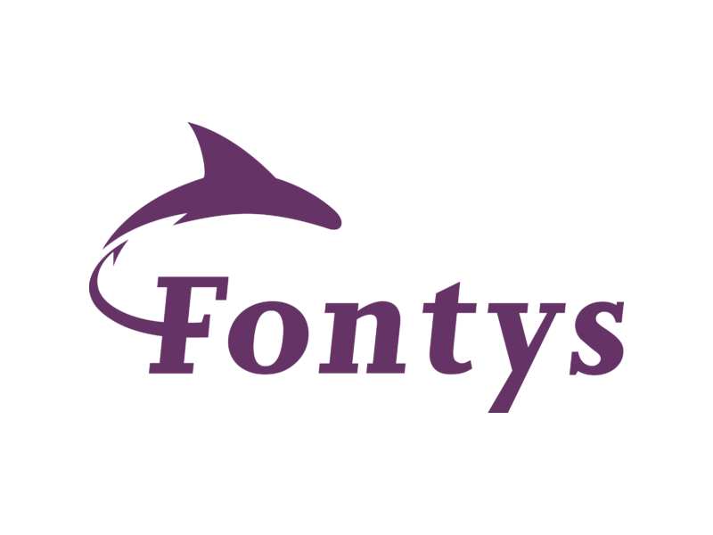
Title Page
Individual Project: Test Plan
Date: 17-05-2024
Developer: Georgi Tinchev (g.tinchev@student.fontys.nl)
Tutor: Bhardwaj Sachin (sachin.bhardwaj@fontys.nl)

Table of Contents
- Title Page
- Table of Contents
- Test Cases + Test Results
- Recommendation for system improvement

Test Cases

Movie Management (FRD-1)
- Add Movie
  - ID: TC-MOV-01
  - Functional Requirement ID: FRD-1
  - Pre-condition: Administrator is logged in.
  - Test Data: Movie details including title, release date, description, poster image URL, trailer URL, runtime, and average rating.
  - Expected Result: Movie added successfully.
- Edit Movie
  - ID: TC-MOV-02
  - Functional Requirement ID: FRD-1
  - Pre-condition: Administrator is logged in.
  - Test Data: Modified movie details.
  - Expected Result: Movie edited successfully.
- Delete Movie
  - ID: TC-MOV-03
  - Functional Requirement ID: FRD-1
  - Pre-condition: Administrator is logged in.
  - Test Data: Movie to be deleted.
  - Expected Result: Movie deleted successfully.

User Management (FRD-2)
- User Registration
  - ID: TC-USER-01
  - Functional Requirement ID: FRD-2
  - Pre-condition: User attempts to register.
  - Test Data: User registration details.
  - Expected Result: User registered successfully.
- User Login
  - ID: TC-USER-02
  - Functional Requirement ID: FRD-2
  - Pre-condition: User attempts to log in.
  - Test Data: User login credentials.
  - Expected Result: User logged in successfully.
- Update User Profile
  - ID: TC-USER-03
  - Functional Requirement ID: FRD-2
  - Pre-condition: User is logged in.
  - Test Data: Modified user profile information.
  - Expected Result: User profile updated successfully.

Genre, Actor, Director Management (FRD-3)
- Add Genre
  - ID: TC-GENRE-01
  - Functional Requirement ID: FRD-3
  - Pre-condition: Administrator is logged in.
  - Test Data: Genre details including name and description.
  - Expected Result: Genre added successfully.
- Edit Genre
  - ID: TC-GENRE-02
  - Functional Requirement ID: FRD-3
  - Pre-condition: Administrator is logged in.
  - Test Data: Modified genre details.
  - Expected Result: Genre edited successfully.
- Delete Genre
  - ID: TC-GENRE-03
  - Functional Requirement ID: FRD-3
  - Pre-condition: Administrator is logged in.
  - Test Data: Genre to be deleted.
  - Expected Result: Genre deleted successfully.
- Add Actor
  - ID: TC-ACTOR-01
  - Functional Requirement ID: FRD-3
  - Pre-condition: Administrator is logged in.
  - Test Data: Actor details including name, bio, and image.
  - Expected Result: Actor added successfully.
- Edit Actor
  - ID: TC-ACTOR-02
  - Functional Requirement ID: FRD-3
  - Pre-condition: Administrator is logged in.
  - Test Data: Modified actor details.
  - Expected Result: Actor edited successfully.
- Delete Actor
  - ID: TC-ACTOR-03
  - Functional Requirement ID: FRD-3
  - Pre-condition: Administrator is logged in.
  - Test Data: Actor to be deleted.
  - Expected Result: Actor deleted successfully.
- Add Director
  - ID: TC-DIRECTOR-01
  - Functional Requirement ID: FRD-3
  - Pre-condition: Administrator is logged in.
  - Test Data: Director details including name, bio, and image.
  - Expected Result: Director added successfully.
- Edit Director
  - ID: TC-DIRECTOR-02
  - Functional Requirement ID: FRD-3
  - Pre-condition: Administrator is logged in.
  - Test Data: Modified director details.
  - Expected Result: Director edited successfully.
- Delete Director
  - ID: TC-DIRECTOR-03
  - Functional Requirement ID: FRD-3
  - Pre-condition: Administrator is logged in.
  - Test Data: Director to be deleted.
  - Expected Result: Director deleted successfully.

User Authentication (FRD-4)
- User Authentication
  - ID: TC-AUTH-01
  - Functional Requirement ID: FRD-4
  - Pre-condition: User attempts to log in.
  - Test Data: User login credentials.
  - Expected Result: User authenticated successfully.

Interpretation Management (FRD-5)
- Submit Interpretation
  - ID: TC-INTERP-01
  - Functional Requirement ID: FRD-5
  - Pre-condition: User is logged in.
  - Test Data: Interpretation content including text and associated movie.
  - Expected Result: Interpretation submitted successfully.

Review Management (FRD-6)
- Submit Review
  - ID: TC-REVIEW-01
  - Functional Requirement ID: FRD-6
  - Pre-condition: User is logged in.
  - Test Data: Review content including rating, text, and associated movie.
  - Expected Result: Review submitted successfully.

Recommendation System (FRD-7)
- View Recommendations
  - ID: TC-RECOMMEND-01
  - Functional Requirement ID: FRD-7
  - Pre-condition: User is logged in.
  - Test Data: User preferences and viewing history.
  - Expected Result: Personalized movie recommendations displayed accurately.

Statistics and Analysis (FRD-8)
- View Analytics
  - ID: TC-ANALYTICS-01
  - Functional Requirement ID: FRD-8
  - Pre-condition: Administrator is logged in.
  - Test Data: System usage data.
  - Expected Result: Accurate statistics and analysis displayed.

Web App Specific Test Cases:

Movie Browsing and Searching (FRW-1)
- Browse Movies
  - ID: TC-WEB-BROWSE-01
  - Functional Requirement ID: FRW-1
  - Pre-condition: User is logged in.
  - Test Data: None.
  - Expected Result: User can view a list of available movies.
- Search Movies
  - ID: TC-WEB-SEARCH-01
  - Functional Requirement ID: FRW-1
  - Pre-condition: User is logged in.
  - Test Data: Search criteria (e.g., movie title).
  - Expected Result: User can search for specific movies and relevant results are displayed.

Profile Management (FRW-3)
- Update Profile
  - ID: TC-WEB-PROFILE-01
  - Functional Requirement ID: FRW-3
  - Pre-condition: User is logged in.
  - Test Data: Modified user profile information.
  - Expected Result: User can update their profile successfully.

Interactivity and Engagement (FRW-4)
- Rate Movie
  - ID: TC-WEB-RATE-01
  - Functional Requirement ID: FRW-4
  - Pre-condition: User is logged in.
  - Test Data: Movie to be rated and rating value.
  - Expected Result: User can rate a movie, and the rating is recorded accurately.
- Submit Interpretation
  - ID: TC-WEB-INTERP-01
  - Functional Requirement ID: FRW-4
  - Pre-condition: User is logged in.
  - Test Data: Interpretation content including text and associated movie.
  - Expected Result: User can submit an interpretation successfully.
- Write Review
  - ID: TC-WEB-REVIEW-01
  - Functional Requirement ID: FRW-4
  - Pre-condition: User is logged in.
  - Test Data: Review content including rating, text, and associated movie.
  - Expected Result: User can write a review for a movie, and the review is saved accurately.

Recommendations and Personalization (FRW-5)
- View Personalized Recommendations
  - ID: TC-WEB-RECOMMEND-01
  - Functional Requirement ID: FRW-5
  - Pre-condition: User is logged in.
  - Test Data: User preferences and viewing history.
  - Expected Result: User receives personalized movie recommendations based on their preferences.

Social Integration (FRW-7)
- Share Movie Recommendation
  - ID: TC-WEB-SHARE-01
  - Functional Requirement ID: FRW-7
  - Pre-condition: User is logged in.
  - Test Data: Movie to be shared.
  - Expected Result: User can share movie recommendations on social media platforms successfully.

Recommendation for system improvement:
After conducting thorough testing based on the defined functional requirements, it is recommended to focus on the following areas to enhance the system's usability and reliability:
- Enhance error handling and validation mechanisms.
- Optimize system performance, especially during peak usage times.
- Implement additional security measures to protect user data and prevent unauthorized access.
- Improve scalability to accommodate future growth in users and data.
- Enhance user interface for better user experience across devices.
This test plan serves as a comprehensive guide to ensure the functionality and performance of the Individual Project's system.

Test Case
Movie
Functional Requirement Desktop App
Functional Requirement Web

